**임베디드 응용 및 실습 7주차 과제**

2022180034 김한별

1. 버튼 입력 받기 구현
2. 스위치 눌렸을 때만 화면에 “click”이 표기되도록 변경

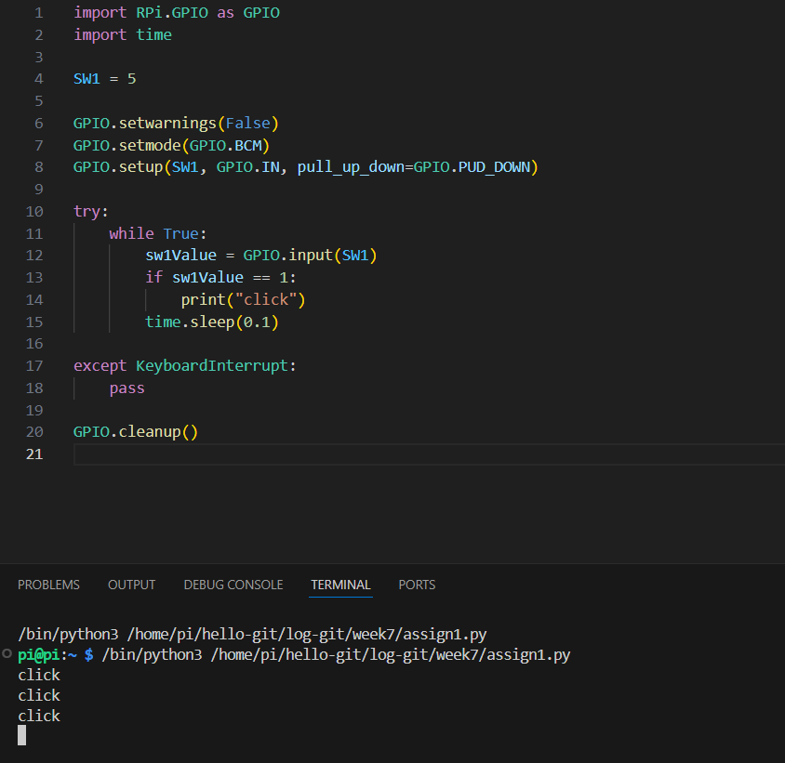

1. 몇번 스위치 눌렸는지 확인 가능하도록 “click X” 화면 출력

import RPi.GPIO as GPIO

import time

SW1 = 5

SW2 = 6

SW3 = 13

SW4 = 19

GPIO.setwarnings(False)

GPIO.setmode(GPIO.BCM)

GPIO.setup(SW1, GPIO.IN, pull_up_down=GPIO.PUD_DOWN)

GPIO.setup(SW2, GPIO.IN, pull_up_down=GPIO.PUD_DOWN)

GPIO.setup(SW3, GPIO.IN, pull_up_down=GPIO.PUD_DOWN)

GPIO.setup(SW4, GPIO.IN, pull_up_down=GPIO.PUD_DOWN)

try:

    while True:

        sw1Value = GPIO.input(SW1)

        sw2Value = GPIO.input(SW2)

        sw3Value = GPIO.input(SW3)

        sw4Value = GPIO.input(SW4)

        if sw1Value == 1:

            print("click 1")

        if sw2Value == 1:

            print("click 2")

        if sw3Value == 1:

            print("click 3")

        if sw4Value == 1:

            print("click 4")

        time.sleep(0.1)

except KeyboardInterrupt:

    pass

GPIO.cleanup()

* 결과

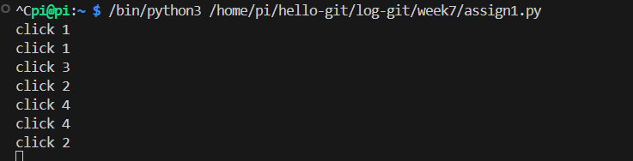

1. 0 -> 1인 경우만 동작 : 1일 때만 click을 프린트할 수 있도록 이미 구현
2. 4개의 스위치 입력 받기, 리스트 활용해 GPIO 전/후 값 저장

import RPi.GPIO as GPIO

import time

SW1 = 5

SW2 = 6

SW3 = 13

SW4 = 19

GPIO.setwarnings(False)

GPIO.setmode(GPIO.BCM)

GPIO.setup(SW1, GPIO.IN, pull_up_down=GPIO.PUD_DOWN)

GPIO.setup(SW2, GPIO.IN, pull_up_down=GPIO.PUD_DOWN)

GPIO.setup(SW3, GPIO.IN, pull_up_down=GPIO.PUD_DOWN)

GPIO.setup(SW4, GPIO.IN, pull_up_down=GPIO.PUD_DOWN)

switch_names = ['SW1', 'SW2', 'SW3', 'SW4']

switch_pins = [SW1, SW2, SW3, SW4]

prev_values = [0, 0, 0, 0]

click_counts = [0, 0, 0, 0]

try:

    while True:

        for i in range(4):

            current_value = GPIO.input(switch_pins[i])

            if prev_values[i] == 0 and current_value == 1:

                click_counts[i] += 1

                print("(", "'", switch_names[i], "click', ", click_counts[i], ")")

            prev_values[i] = current_value

        time.sleep(0.1)

except KeyboardInterrupt:

    pass

GPIO.cleanup()

* 결과

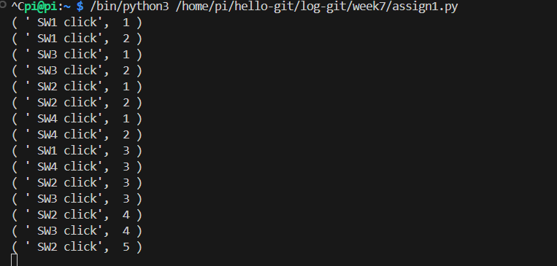

1. 부저 음계 출력 구현 -> 결과 동영상 참고
2. “도레미파솔라시도” 음계 출력

import RPi.GPIO as GPIO

import time

BUZZER = 12

GPIO.setwarnings(False)

GPIO.setmode(GPIO.BCM)

GPIO.setup(BUZZER, GPIO.OUT)

p = GPIO.PWM(BUZZER, 261)

p.start(50)

try:

    while True:

        p.start(50)

        p.ChangeFrequency(262)

        time.sleep(1.0)

        p.ChangeFrequency(292)

        time.sleep(1.0)

        p.ChangeFrequency(330)

        time.sleep(1.0)

        p.ChangeFrequency(349)

        time.sleep(1.0)

        p.ChangeFrequency(394)

        time.sleep(1.0)

        p.ChangeFrequency(440)

        time.sleep(1.0)

        p.ChangeFrequency(494)

        time.sleep(1.0)

        p.ChangeFrequency(523)

        time.sleep(1.0)

        p.stop()

        time.sleep(1.0)

except KeyboardInterrupt:

    pass

p.stop()

GPIO.cleanup()

(2) 나만의 경적 소리 구현

import RPi.GPIO as GPIO

import time

BUZZER = 12

GPIO.setwarnings(False)

GPIO.setmode(GPIO.BCM)

GPIO.setup(BUZZER, GPIO.OUT)

p = GPIO.PWM(BUZZER, 261)

p.start(50)

try:

    while True:

        p.start(50)

        p.ChangeFrequency(262)

        time.sleep(0.3)

        p.ChangeFrequency(330)

        time.sleep(0.3)

        p.ChangeFrequency(394)

        time.sleep(0.3)

        p.ChangeFrequency(262)

        time.sleep(0.3)

        p.ChangeFrequency(330)

        time.sleep(0.3)

        p.ChangeFrequency(394)

        time.sleep(0.3)

        p.ChangeFrequency(523)

        time.sleep(0.8)

        p.stop()

        time.sleep(1.0)

except KeyboardInterrupt:

    pass

p.stop()

GPIO.cleanup()

(3) 스위치를 한번 누르면 경적 소리가 나도록 구현

import RPi.GPIO as GPIO

import time

BUZZER = 12

SW1 = 5

GPIO.setwarnings(False)

GPIO.setmode(GPIO.BCM)

GPIO.setup(BUZZER, GPIO.OUT)

GPIO.setup(SW1, GPIO.IN, pull_up_down=GPIO.PUD_DOWN)

p = GPIO.PWM(BUZZER, 261)

p.start(50)

try:

    while True:

        sw1Value = GPIO.input(SW1)

        if sw1Value == 1:

            p.start(50)

            p.ChangeFrequency(262)

            time.sleep(0.3)

            p.ChangeFrequency(330)

            time.sleep(0.3)

            p.ChangeFrequency(394)

            time.sleep(0.3)

            p.ChangeFrequency(262)

            time.sleep(0.3)

            p.ChangeFrequency(330)

            time.sleep(0.3)

            p.ChangeFrequency(394)

            time.sleep(0.3)

            p.ChangeFrequency(523)

            time.sleep(0.8)

        p.stop()

except KeyboardInterrupt:

    pass

p.stop()

GPIO.cleanup()

(4) 스위치 4개를 사용해 나만의 음악을 연주

import RPi.GPIO as GPIO

import time

BUZZER = 12

SW1 = 5

SW2 = 6

SW3 = 13

SW4 = 19

GPIO.setwarnings(False)

GPIO.setmode(GPIO.BCM)

GPIO.setup(BUZZER, GPIO.OUT)

GPIO.setup(SW1, GPIO.IN, pull_up_down=GPIO.PUD_DOWN)

GPIO.setup(SW2, GPIO.IN, pull_up_down=GPIO.PUD_DOWN)

GPIO.setup(SW3, GPIO.IN, pull_up_down=GPIO.PUD_DOWN)

GPIO.setup(SW4, GPIO.IN, pull_up_down=GPIO.PUD_DOWN)

p = GPIO.PWM(BUZZER, 261)

try:

    while True:

        sw1Value = GPIO.input(SW1)

        sw2Value = GPIO.input(SW2)

        sw3Value = GPIO.input(SW3)

        sw4Value = GPIO.input(SW4)

        if sw1Value == 1:

            p.start(50)

            p.ChangeFrequency(292)

            time.sleep(0.3)

        elif sw2Value == 1:

            p.start(50)

            p.ChangeFrequency(330)

            time.sleep(0.3)

        elif sw3Value == 1:

            p.start(50)

            p.ChangeFrequency(394)

            time.sleep(0.3)

        elif sw4Value == 1:

            p.start(50)

            p.ChangeFrequency(440)

            time.sleep(0.3)

        else:

            p.stop()

except KeyboardInterrupt:

    pass

p.stop()

GPIO.cleanup()

1. 자동차 움직이기 구현 -> 결과 동영상 참고
2. 오른쪽 모터부분의 코드를 추가해 정방향으로 50%로 동작 -> 정지 -> 동작 …

import RPi.GPIO as GPIO

import time

PWMA = 18

PWMB = 23

AIN1 = 22

AIN2 = 27

BIN1 = 25

BIN2 = 24

GPIO.setwarnings(False)

GPIO.setmode(GPIO.BCM)

GPIO.setup(PWMA, GPIO.OUT)

GPIO.setup(PWMB, GPIO.OUT)

GPIO.setup(AIN1, GPIO.OUT)

GPIO.setup(AIN2, GPIO.OUT)

GPIO.setup(BIN1, GPIO.OUT)

GPIO.setup(BIN2, GPIO.OUT)

L_Motor = GPIO.PWM(PWMA, 500)

L_Motor.start(0)

R_Motor = GPIO.PWM(PWMB, 500)

R_Motor.start(0)

try:

    while True:

        GPIO.output(AIN1, 0)

        GPIO.output(AIN2, 1)

        L_Motor.ChangeDutyCycle(100)\

        GPIO.output(BIN1, 0)

        GPIO.output(BIN2, 1)

        R_Motor.ChangeDutyCycle(50)

        time.sleep(1.0)

        GPIO.output(AIN1, 0)

        GPIO.output(AIN2, 1)

        GPIO.output(BIN1, 0)

        GPIO.output(BIN2, 1)

        L_Motor.ChangeDutyCycle(0)

        R_Motor.ChangeDutyCycle(0)

        time.sleep(1.0)

except KeyboardInterrupt:

    pass

GPIO.cleanup()

1. 스위치를 입력 받아 자동차 조종하기 (SW1 앞, SW2 오른쪽, SW3 왼쪽, SW4 뒤)

import RPi.GPIO as GPIO

import time

PWMA = 18

PWMB = 23

AIN1 = 22

AIN2 = 27

BIN1 = 25

BIN2 = 24

SW1 = 5

SW2 = 6

SW3 = 13

SW4 = 19

GPIO.setwarnings(False)

GPIO.setmode(GPIO.BCM)

GPIO.setup(PWMA, GPIO.OUT)

GPIO.setup(PWMB, GPIO.OUT)

GPIO.setup(AIN1, GPIO.OUT)

GPIO.setup(AIN2, GPIO.OUT)

GPIO.setup(BIN1, GPIO.OUT)

GPIO.setup(BIN2, GPIO.OUT)

GPIO.setup(SW1, GPIO.IN, pull_up_down=GPIO.PUD_DOWN)

GPIO.setup(SW2, GPIO.IN, pull_up_down=GPIO.PUD_DOWN)

GPIO.setup(SW3, GPIO.IN, pull_up_down=GPIO.PUD_DOWN)

GPIO.setup(SW4, GPIO.IN, pull_up_down=GPIO.PUD_DOWN)

L_Motor = GPIO.PWM(PWMA, 500)

L_Motor.start(0)

R_Motor = GPIO.PWM(PWMB, 500)

R_Motor.start(0)

try:

    while True:

        sw1Value = GPIO.input(SW1)

        sw2Value = GPIO.input(SW2)

        sw3Value = GPIO.input(SW3)

        sw4Value = GPIO.input(SW4)

        if sw1Value == 1:

            print("sw1 버튼 입력")

            GPIO.output(AIN1, 0)

            GPIO.output(AIN2, 1)

            L_Motor.ChangeDutyCycle(100)

            GPIO.output(BIN1, 0)

            GPIO.output(BIN2, 1)

            R_Motor.ChangeDutyCycle(100)

            time.sleep(1)

        elif sw2Value == 1:

            print("sw2 버튼 입력")

            GPIO.output(AIN1, 0)

            GPIO.output(AIN2, 1)

            L_Motor.ChangeDutyCycle(100)

            GPIO.output(BIN1, 1)

            GPIO.output(BIN2, 0)

            R_Motor.ChangeDutyCycle(100)

            time.sleep(1)

        elif sw3Value == 1:

            print("sw3 버튼 입력")

            GPIO.output(AIN1, 1)

            GPIO.output(AIN2, 0)

            L_Motor.ChangeDutyCycle(100)

            GPIO.output(BIN1, 0)

            GPIO.output(BIN2, 1)

            R_Motor.ChangeDutyCycle(100)

            time.sleep(1)

        elif sw4Value == 1:

            print("sw4 버튼 입력")

            GPIO.output(AIN1, 1)

            GPIO.output(AIN2, 0)

            L_Motor.ChangeDutyCycle(100)

            GPIO.output(BIN1, 1)

            GPIO.output(BIN2, 0)

            R_Motor.ChangeDutyCycle(100)

            time.sleep(1)

        L_Motor.ChangeDutyCycle(0)

        R_Motor.ChangeDutyCycle(0)

        time.sleep(0.1)

except KeyboardInterrupt:

    pass

GPIO.cleanup()

* 프린트문 결과

